U.S. Capitol Visitor CenterGetting to the Capitol
Walking to the Capitol
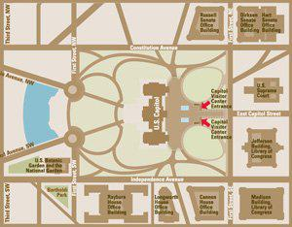
The United States Capitol is bordered by Constitution Avenue to the north, Independence Avenue to the south, and First Streets, to the east and west. It is located at the far eastern end of the National Mall beyond the Capitol Reflecting Pool.
The Capitol grounds are open to visitors.

Getting to the Capitol by Car
Please keep in mind that there is very little public parking available near the Capitol. The nearest public parking facility is at Union Station, to the north of the Capitol.
Metered street parking is found along the Mall to the west of the Capitol.

Getting to the Capitol by Subway
There are three subway stops found within walking distance of the Capitol:
- Union Station – Located at First Street, NW, and Massachusetts Avenue.
- Capitol South – Located at First Street between C and D Streets, SE.
- Federal Center, SW – Located at the southwest corner of Third and D Streets, SW.
Additional information on riding the subway, which is called the Metro, is available at the Washington Metropolitan Area Transit Authority homepage here.

Tips for Visiting the Capitol
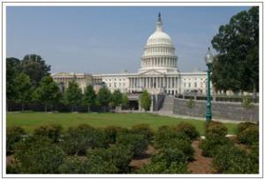

Plan ahead

Come by Public Transportation
Avoid the frustration of looking for a parking spot by taking public transportation to the Capitol. Two Metrorail stops, Union Station and Capitol South, are close by. Additional information on riding Metro is available at the Washington Metropolitan Transit Authority homepage here.

Allow Enough Time
Factor in time to get to the Capitol. No matter your method of transportation, you may find yourself with several blocks of walking to do before you arrive at the Visitor Center. Event attendees can access Security Screening zones at 1:45p.m. Only attendees listed on the Hawai`i State Society Kamehameha Lei Draping Ceremony Registry will be allowed to proceed. The Kamehameha Lei Draping Ceremony will begin promptly at 2:30p.m.

Prohibited Items
Capitol visitor policies are designed to keep visitors and staff safe and secure and to preserve the collections, facilities, and historic building and grounds for generations to come.

Before entering the Capitol Visitor Center, all visitors are screened by a magnetometer and all items that are permitted inside the building are screened by an x-ray device. The following items are strictly prohibited in the Capitol, including the Capitol Visitor Center:

- Liquid, including water
- Food or beverages of any kind, including fruit and unopened packaged food
- Aerosol containers
- Non-aerosol spray (Prescriptions for medical needs are permitted.)
- Any pointed object, e.g. knitting needles and letter openers (Pens and pencils are permitted.)
- Any bag larger than 18" wide x 14" high x 8.5" deep
- Electric stun guns, martial arts weapons or devices
- Guns, replica guns, ammunition, and fireworks
- Knives of any size
- Mace and pepper spray
- Razors and box cutters

Please note that the U.S. Capitol Police are authorized to make exceptions if a prohibited item is determined to be necessary and required to serve child care, medical or other special needs. If you have questions, please call the Office of Congressional Accessibility Services at 202.224.4048

Emergency Evacuation Information
In the event of an emergency, please follow the guidance of U.S.Capitol Police Officers. To report an emergency or suspicious activity, please inform the nearest U.S. Capitol Police Officer. Detailed emergency evacuation information is available here.

Visitors with Disabilities
Visitors with Disabilities
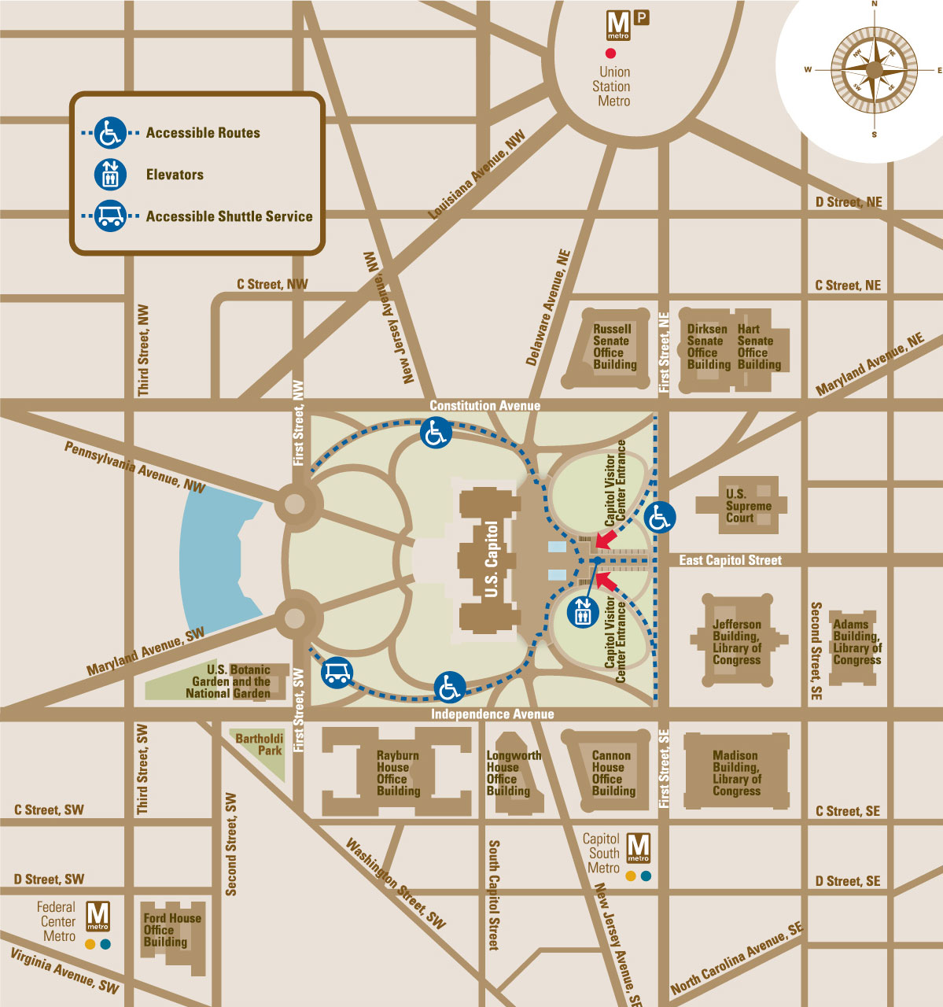
- Wheelchairs may be requested up to 5 days prior to the Kamehameha Lei Draping Ceremony. Contact dbutts@makakoaenterprises.com,
- Family Restrooms are available throughout the Capitol Visitor Center.
- Service animals are allowed in the Visitor Center and the Capitol.
- A public TTY is located near one of the gift shops on the Upper Level.
- Copies of all Capitol Visitor Center brochures in alternative formats (large print, braille, HTML) are available at the Information Desks.
- Emergency evacuation information for visitors with disabilities is available here.
- Additional information on accessibility in the Capitol and the House and Senate Office Buildings is available at the Architect of the Capitol's Web site here.

- If you have any accessibility questions, please call the Office of Congressional Accessibility Services at 202-224-4048202-224-4048.

U.S. Capitol Visitor Center Map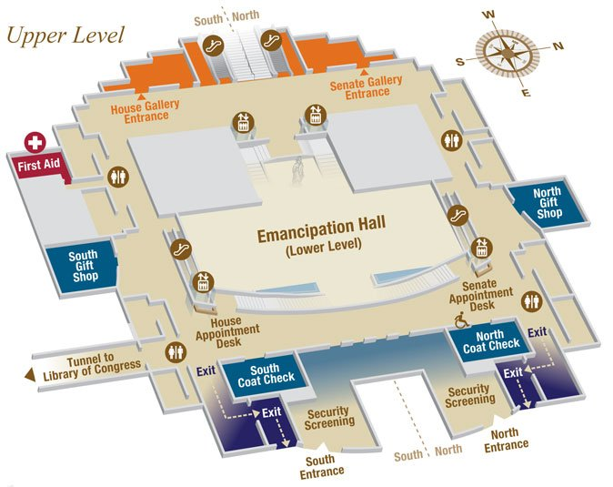
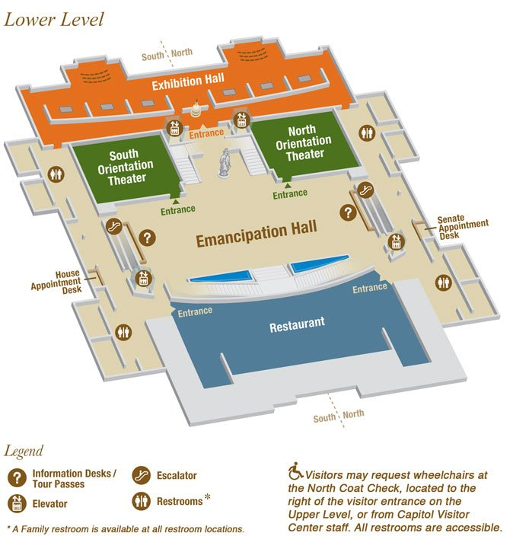

Click here for a printer friendly version of the U.S. Capitol Visitor Guide.

